3. The online bus ticket booking system enables users to search for buses by route, date, and time, and view available seats. Users can create an account, log in, and manage their bookings through a personal dashboard. The booking process includes selecting seats, filling out passenger details, and making secure payments via an integrated payment gateway. Admins can manage bus schedules, seat availability, and user accounts through an admin panel. Users receive booking confirmation emails and can view their booking history. The website is mobile-responsive, ensuring easy access on all devices.
Admin :
In this system, the admin can maintain all the Bus information and maintain Bus category, comments etc.In this system, the admin can maintain the registered users, manage news, and the admin can generate reports and manage the whole system.
Login:
Login Module includes various utilities like User Authentication, Change Password and Forgot Password.
Registration:
This website provides some facilities users can be Registered in this website. user can use this facility so user can make a registration
Book the Ticket:
In this module, the admin can add a new bus category using this module. Bus Category contains like Volvo, Slipper coach, coach etc.
Update Bus Information:
In this module, the admin can add or Update Bus using this module. It contains information about the Bus type, photo, description, Location of the tour, Available Seats in Bus etc.
Cancel the Booking Ticket:
In this Module, the User can cancel the booking Ticket.
Comments:
In this Module, Users can Post Comments on a particular Bus.
Report Generation:
This module is used to generate a report.

SAMPLE CODE:
<!DOCTYPE html>
<html>
<head>
<title>Bus Ticket Booking</title>
<style>
body { font-family: Arial; margin: 25px; background: #f2f6f8; }
section { background: white; padding: 15px; margin: 12px 0; }
input, button { padding: 9px; margin: 4px; }
button { background: #18546b; color: white; border: 0; }
</style>
</head>
<body>
<h1>Bus Ticket Booking System</h1>
<section>
<h2>Search Buses</h2>
<input id="from" placeholder="From">
<input id="to" placeholder="To">
<input id="date" type="date">
<button onclick="searchBuses()">Search</button>
<div id="results"></div>
</section>
<section>
<h2>Passenger Details</h2>
<input id="passenger" placeholder="Passenger name">
<input id="email" type="email" placeholder="Email">
<div id="bookings"></div>
</section>

<section>
<h2>Admin: Add a Bus</h2>
<input id="busName" placeholder="Bus name or category">
<input id="busFrom" placeholder="From">
<input id="busTo" placeholder="To">
<button onclick="addBus()">Add Bus</button>
</section>
<script>
const buses = [
{ name: "Volvo Coach", from: "Chennai", to: "Bengaluru", seats: 20 },
{ name: "Sleeper Coach", from: "Chennai", to: "Coimbatore", seats: 15 }
];
const bookings = [];
function searchBuses() {
const from = document.getElementById("from").value.toLowerCase();
const to = document.getElementById("to").value.toLowerCase();
const matches = buses.filter(bus =>
bus.from.toLowerCase().includes(from) &&
bus.to.toLowerCase().includes(to) &&
bus.seats > 0
);
document.getElementById("results").innerHTML = matches.map(bus => `
<p>${bus.name}: ${bus.from} to ${bus.to}
— ${bus.seats} seats available
<button onclick="book('${bus.name}')">Book Seat</button></p>
`).join("") || "No buses found.";
}
function book(busName) {
const name = document.getElementById("passenger").value.trim();
const email = document.getElementById("email").value.trim();
if (!name || !email) {
alert("Enter your name and email first.");
return;
}
const bus = buses.find(item => item.name === busName);
bus.seats--;
bookings.push({ name, email, bus: busName });
alert("Ticket booked. Payment is simulated.");
showBookings();
searchBuses();
}
function showBookings() {
document.getElementById("bookings").innerHTML =
bookings.map((booking, index) => `
<p>${booking.name} — ${booking.bus}
<button onclick="cancelBooking(${index})">Cancel</button></p>
`).join("");
}
function cancelBooking(index) {
const booking = bookings.splice(index, 1)[0];
buses.find(bus => bus.name === booking.bus).seats++;
showBookings();
searchBuses();
}
function addBus() {
buses.push({
name: document.getElementById("busName").value,
from: document.getElementById("busFrom").value,
to: document.getElementById("busTo").value,
seats: 20
});
alert("Bus added.");
searchBuses();
}
</script>
</body>
</html>
SAMPLE OUTPUT
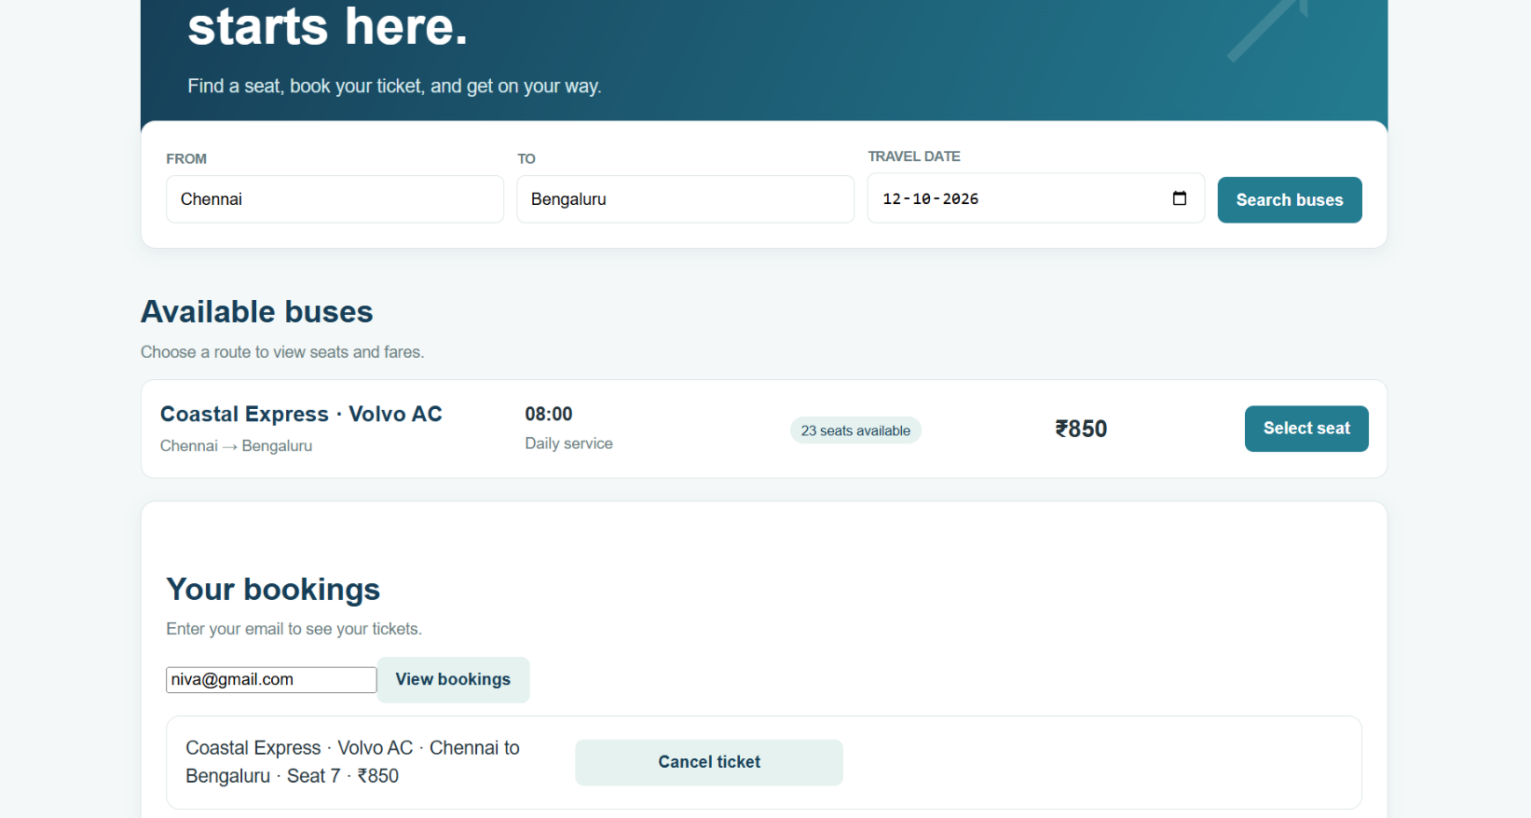
PASSENGER VIEW:

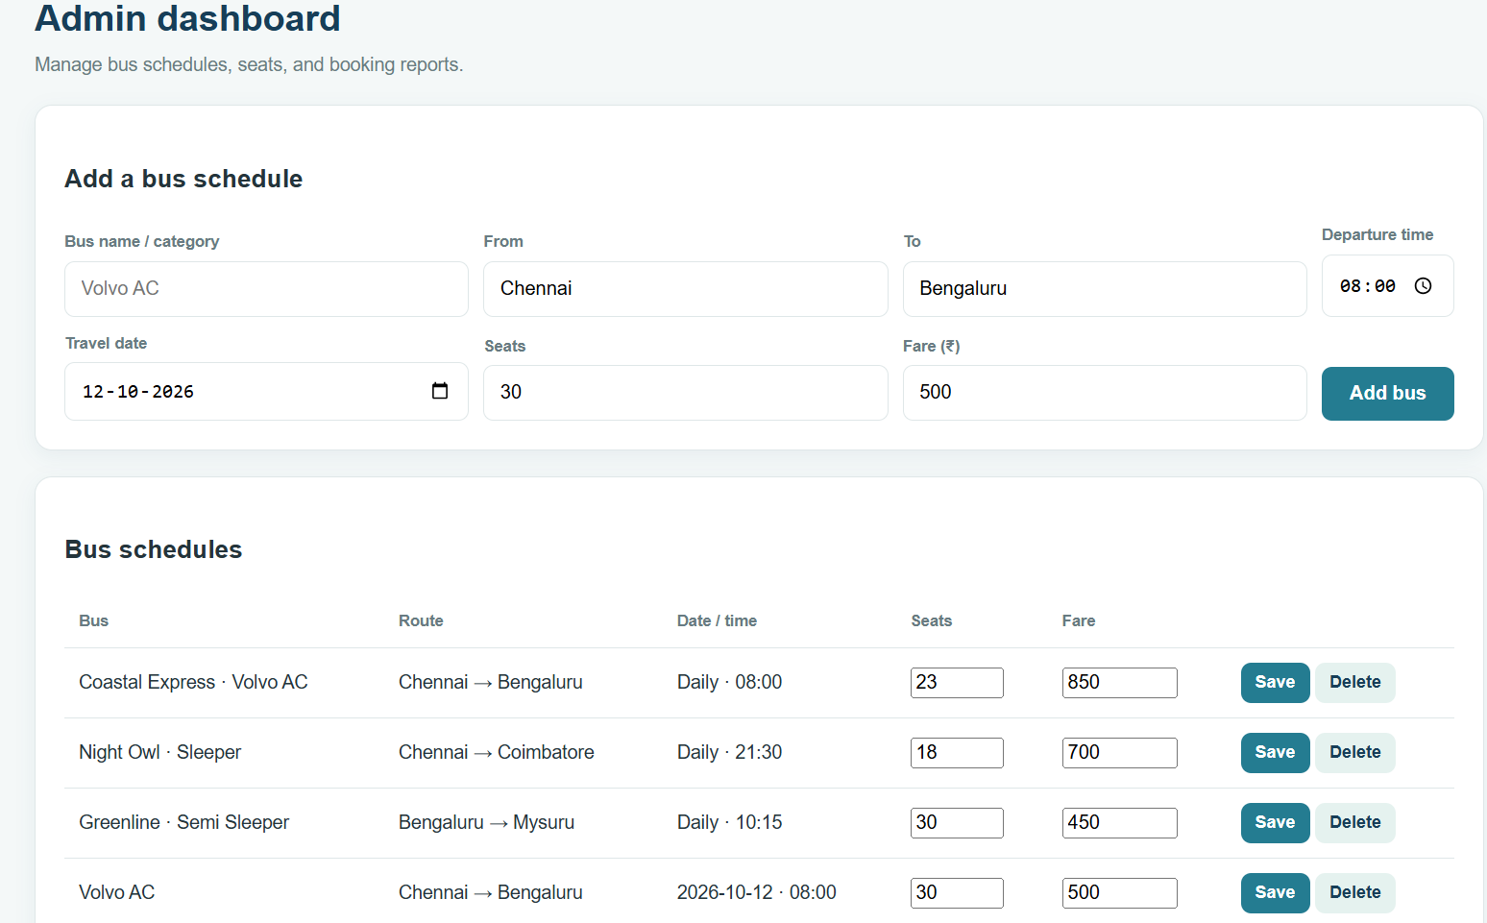
ADMIN PANEL

